**Ana P.**

**VEGAN BLUEBERRY MUFFIN**

*These vegan muffins are moist, rich, and bursting with blueberries*

*and lemon zest in every bite. They are the perfect morning pastry or*

*a midday snack.*

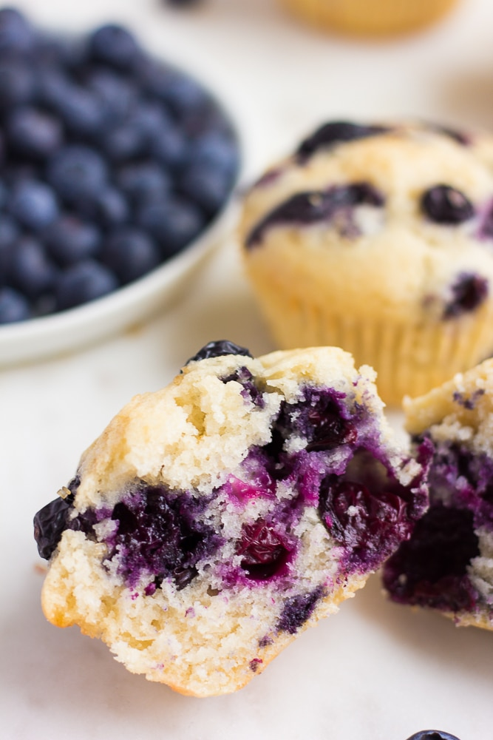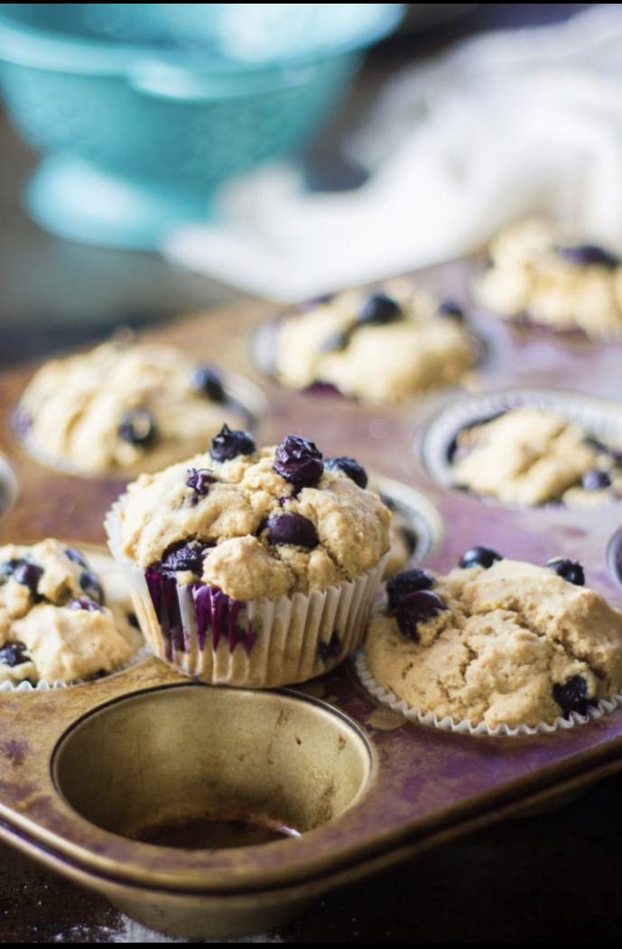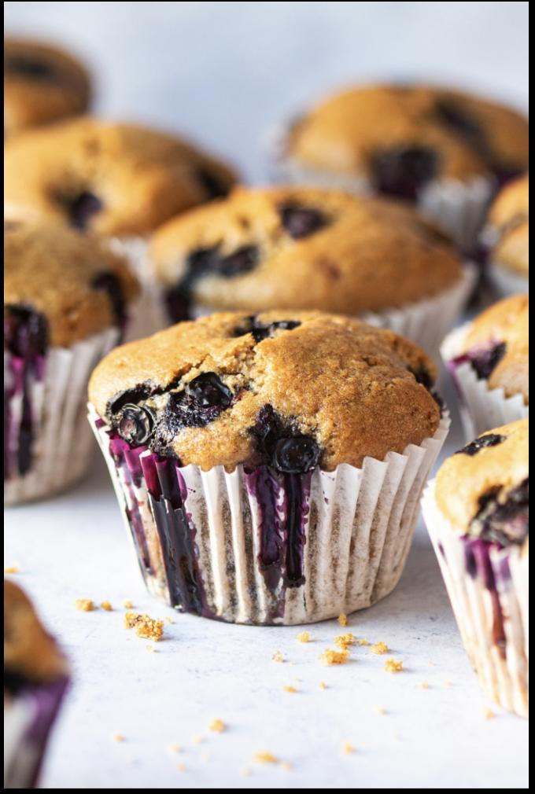

**Prep time: 10 min.**

**Cook time: 20 min.**

**Servings: 12**

**INGREDIENTS:**

* 1 cup soy milk
* 1 teaspoon apple cider vinegar
* 2 cups all-purpose flour
* 2½ teaspoons baking powder
* ¼ teaspoon baking soda
* ½ teaspoon salt
* ½ cup + 2tbsp. granulated sugar
* ¼ cup + 2 tbsp. canola oil
* 1 teaspoon vanilla extract
* zest of 1 lemon
* 1½ – 2 cups fresh blueberries

**INSTRUCTIONS:**

**1.**Preheat the oven to 375F. Spray a muffin tinwith cooking spray and set aside.

**2.**In a small bowl combine soy milk and apple cider vinegar. Set aside to allow milk to curdle.

**3.**In a larger bowl combine flour, baking powder, baking soda, and salt. Set aside. In a separate bowl, mix together sugar, canola oil, lemon zest, and vanilla extract. Add soy milk/vinegar mixture and stir to combine. Stir in the dry ingredients until well incorporated. Be careful not to over-mix – a few lumps are okay. Gently fold in the blueberries.

**4.**Spoon into muffin tins, filling each cup about ¾ full. Bake for 20-25 minutes until a knife inserted in the middle comes out clean.

**5.**Remove from heat and allow muffins to cool before removing from the pan.

**BUDDHA BOWL**

*The beauty of grain bowls is that they are infinitely adaptable.*

*This Buddha Bowl is packed with all types of healthy nutrients,*

*and is full of flavor.*

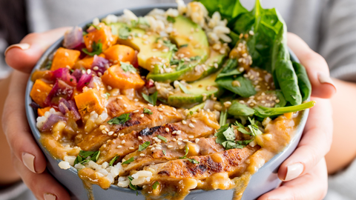

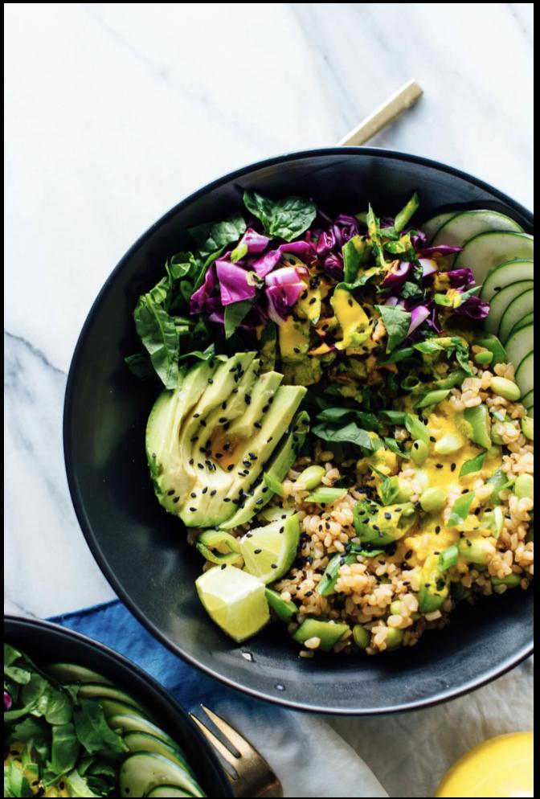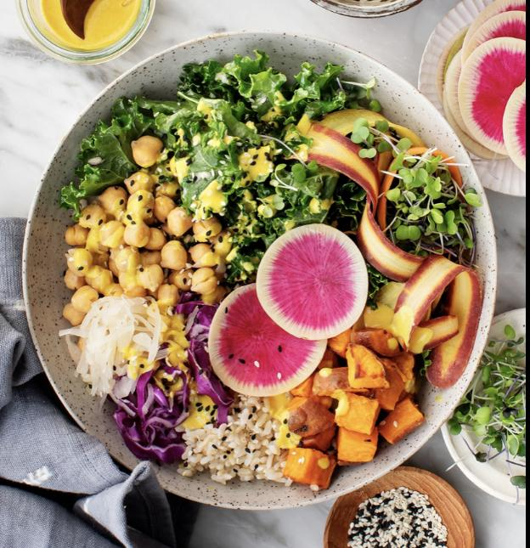

**Prep time: 10 min.**

**Cook Time: 30 min.**

**Servings: 4**

**INGREDIENTS**

* 1 large sweet potato, peeled and cut into 1/2-inch cubes
* 1 large red onion, diced
* 3 tbsp. extra-virgin olive oil, divided
* Kosher salt
* Freshly ground black pepper
* 1 lb. boneless, skinless chicken breasts (*replace with tofu for veg. opt.)
* 1/2 tsp. garlic powder
* 1/2 tsp. ground ginger
* 1 small clove garlic, minced
* 2 tbsp. creamy peanut butter
* 1/4 c. Juice of 1 lime
* 1 tbsp. low-sodium soy sauce
* 1 tbsp. honey
* 1 tbsp. toasted sesame oil
* 4 c. cooked brown rice
* 1 avocado, thinly sliced
* 2 c. baby spinach
* 1 tbsp. Freshly chopped cilantro, for garnish
* 1 tsp. Toasted sesame seeds
* **1.** Preheat the oven to 425°. On a large baking sheet, toss sweet potatoes and onion with 1 tablespoon of oil and season with salt and pepper. Bake until tender, 20 to 25 minutes.
* **2.** Meanwhile, in a large skillet over medium- high heat, heat 1 tablespoon of oil. Season chicken with garlic powder, ginger, salt, and pepper. Cook until golden and no longer pink, 8 minutes per side. Let rest 10 minutes, then slice.
* **3.** In a small bowl, whisk together garlic, peanut butter, lime juice, soy sauce, and honey. Whisk in sesame oil and remaining 1 tablespoon olive oil until smooth.
* **4.** Divide rice among four bowls and top each with sweet potato mixture, chicken, avocado, and baby spinach. Sprinkle with cilantro and sesame seeds and drizzle with dressing before serving.